*LAB # 13*

implementating hashing & collision resolution techniques

# *OBJECTIVE:*

*implementating hashing & collision resolution techniques*

*LAB task*

1. *Write a program which shows the insertion of the elements in a hashtable.*

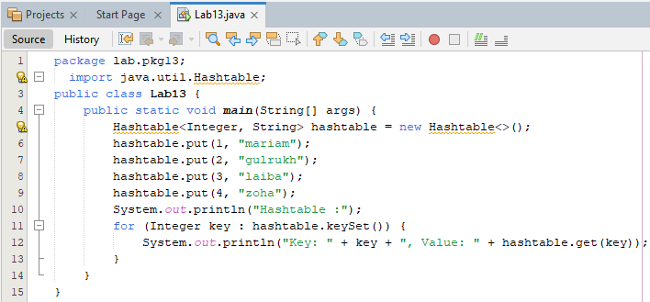

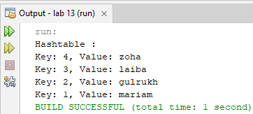

1. *Create a HashMap object called Vehicles which store String keys and String values and perform add( ), remove( ) and search( ) methods on it.*

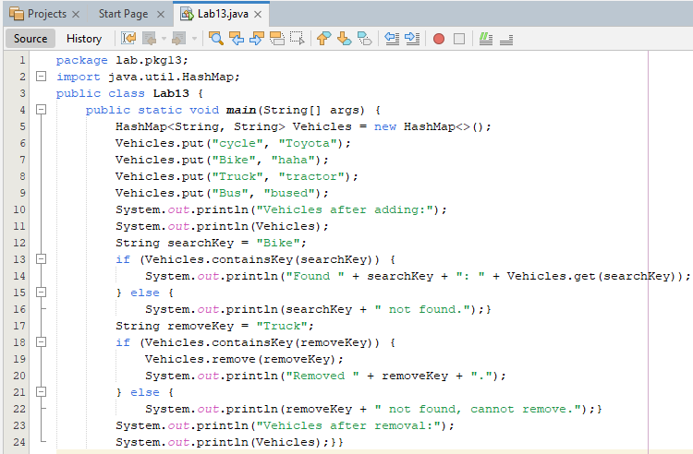

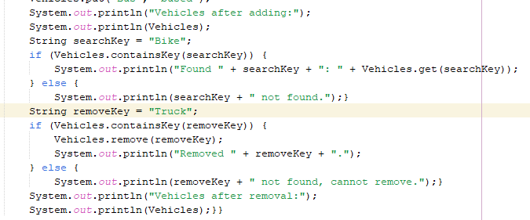

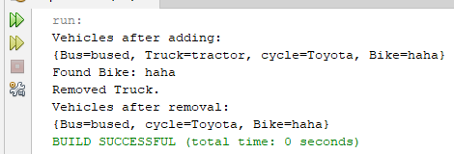

*3.Given an array of integers, write a Java program to find the most frequent element in the array. If there are multiple elements with the same frequency, return the one with the smallest value. Use a HashMap to count the frequency of each element and identify the most frequent one.*

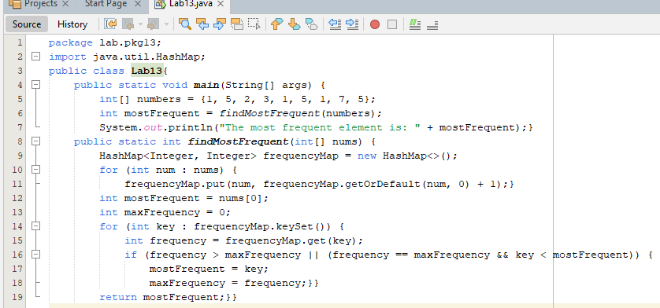



*4.Use a HashMap to store the cumulative sum of elements and count how often a sum has occurred. 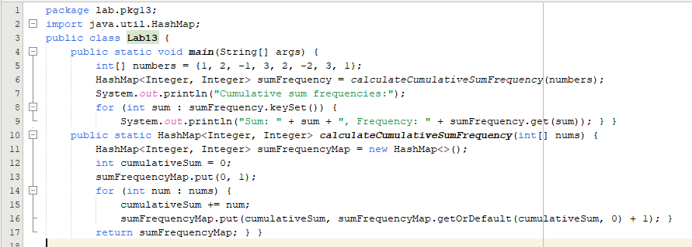*

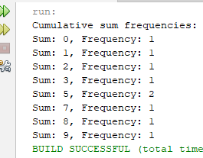

***HOME TASKS***

1. *Enter data of a cricket team 11 players which is supposed to be a hash table value and insert runs of each player as a data, find out key treat’s Rank# of a player. For example: Runs are 30 mod by 11 which is index no 8; rank#8 is a rank of a team member. (Use HashTable ADT class)*

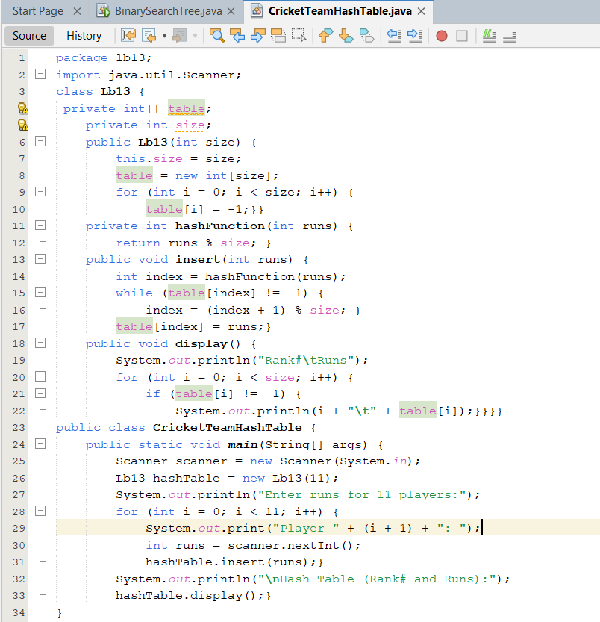

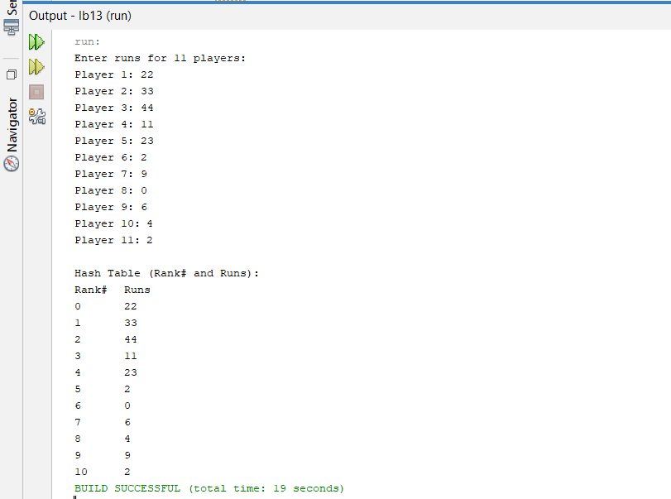

1. *Harold is a kidnapper who wrote a ransom note, but now he is worried it will be traced back to him through his handwriting. He found a magazine and wants to know if he can cut out whole words from it and use them to create an untraceable replica of his ransom note. The words in his note are case-sensitive and he must use only whole words available in the magazine. He cannot use substrings or concatenation to create the words he needs.Given the words in the magazine and the words in the ransom note, print****Yes****if he can replicate his ransom note exactly using whole words from the magazine; otherwise, print****No****.*

*Example:  
magazine = "attack at dawn" note = "Attack at dawn"*

*The magazine has all the right words, but there is a case mismatch. The answer is* ***No****.*

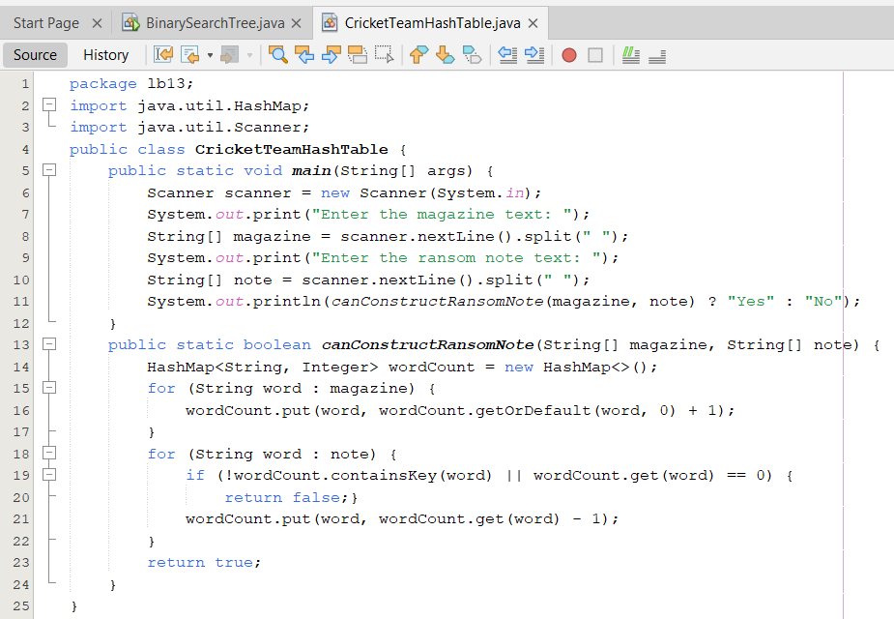

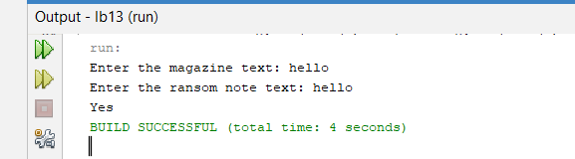

***3.Scenario:*** *You are building an analytics tool for a website. The tool needs to count the number of visitors to each page and store the data. Write a Java program that uses a HashMap to track the number of visits to different pages of a website. Each time a visitor accesses a page, the tool should increment the visit count for that page.*

***Requirements:***

1. *The key should be the page URL (as a string), and the value should be the number of visits (as an integer).*
2. *Provide a method to retrieve the visit count for a given page.*
3. *Provide a method to get the page with the highest visit count.*

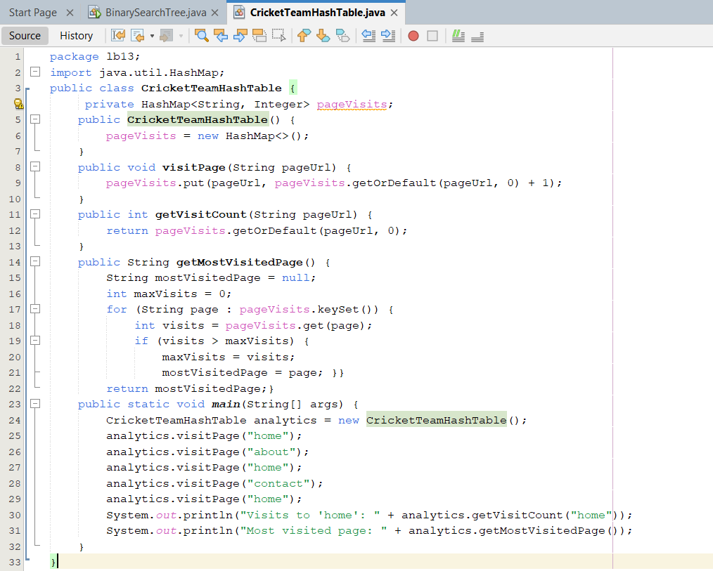

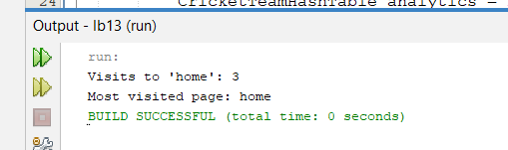

***4.Scenario:*** *You are developing a system to track student grades. The system should store the grades for each student in a course and calculate the average grade. Use a HashMap where the key is the student name (string) and the value is their grade (integer). The system should be able to add new students, update existing students' grades, and calculate the class average.*

***Requirements:***

1. *Implement methods to:*
   * *Add or update student grades.*
   * *Get the grade of a specific student.*
   * *Calculate and return the class average grade.*
2. *Handle edge cases, such as when no students have been added yet.*

